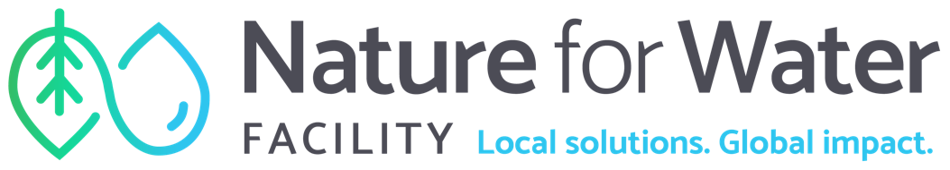



Pre-feasibility Analysis for Watershed Investment Programs

Terms of Reference

June 2022
Contents
1. Background 3
1.1. Water security and Nature-based Solutions 3
1.2. Watershed Investment Programs (WIPs) 3
2. Objectives and activities 4
2.1. Purpose of the Pre-Feasibility Phase 4
2.2. Requirements of the Pre-Feasibility Analysis 4
Deliverable 1: Stakeholder Outreach Assessment 4
Deliverable 2: Pre-feasibility Analysis Report 5
3. Minimum required activities beyond deliverables 8
4. Assignment timeframes and deliverables 8
5. Experience requirements 9
Annex A. WIP lifecycle 10
Annex B. WIP partners 11
Annex C. Sample interview questions 12
Annex D. Typical watershed stakeholders and funding 13
Annex E. Potential WIP governance models 14
Annex F. Indicative Theory of Change 16
Annex G. Suggested Timeline 17

Background
  - Water security and Nature-based Solutions
Water security – defined as the availability of an acceptable quantity and quality of water for health, livelihoods, ecosystems, and production, coupled with an adequate level of water-related risks to people, environments, and economies– is a global challenge. The water we use every day is directly dependent on the landscapes through which it flows, yet nearly half of global drinking water sources are significantly degraded. Compounding factors, such as population growth, climate change, and poor planning are only further exacerbating water insecurity. By 2025, almost 70% of the world’s population is expected to be living in water-stressed areas.

To tackle water insecurity, we urgently need to restore resilient, healthy watersheds, from where our water is sourced. Nature-based solutions for water security (NbS-WS) offer a promising path forward to address the twin crises of water and climate. NbS-WS are actions to protect, sustainably manage and restore natural or modified ecosystems that address water security challenges. These natural solutions support human wellbeing and ecosystems and take a systems approach to consider multiple aspects in a watershed (e.g., upstream users and land use patterns). Watershed Investment Programs (WIPs) are initiatives designed to deliver water security benefits by deploying a defined portfolio of NbS interventions within a specified service area.

  - Watershed Investment Programs (WIPs)

A Watershed Investment Program (WIP) is an initiative designed to deliver ecosystem services (e.g., filtration, flood control, etc.) by investing in the protection or restoration of nature. WIPs aims to deliver water security and associated co-benefit outcomes via a defined portfolio of NbS interventions within a specified service area (the “NbS Investment Portfolio”). A WIP is a programmatic approach for delivering Watershed Investments, which are defined as transactions between a service provider and payer or beneficiary where financial or economic value is exchanged for activities or outcomes associated with the maintenance, restoration, or enhancement of natural areas considered important for watershed services (Forest Trends 2016).

Water security is a complex, multi-layered, and interconnected societal and environmental issue. To succeed, solutions need to be equally as holistic, well-informed, multi-layered, and adaptive. Key aspects of WIP development include:

- A thorough multi-stakeholder process that involves upstream and downstream stakeholders in development and decision-making to garner participation and endorsement, motivate investment, and mitigate conflicting interests.
- Adaptable and customizable to diverse contexts and scales, rather than prescriptive.
- Focused on long-term impact and an ability to clearly quantify, evaluate, and report outcomes at each stage of the WIP development process.
- Science-based approach that relies on information systems to link NbS intervention activities to ecosystem services and overall watershed context.

The WIP process is composed of four interconnected phases—Pre-Feasibility, Feasibility, Design, and Execution—grouped into Program Preparation and Program Implementation (Annex A).

Objectives and activities

  - Purpose of the Pre-Feasibility Phase
This Terms of Reference is for the first phase of a WIP – the Pre-Feasibility Phase. The Pre-Feasibility phase is a crucial first phase of exploration and seeks to understand the high-level basin context and the potential additionality and enabling conditions for WIP establishment. Key goals of the phase include understanding the watershed’s stakeholder landscape, identifying water security challenges and potentially relevant Nature-based Solutions, and determining whether to move forward and commit additional resources to advancing Feasibility phase with the support of your stakeholder group.

  - Requirements of the Pre-Feasibility Analysis
The Pre-Feasibility Analysis is a holistic analytical package that provides a rough scoping for your WIP and creates an interface point for stakeholders to register their interest and support. It typically culminates with a Go/No-Go Evaluation, and in the case of ‘Go’ the signing of an In-Principles Agreement with your core stakeholders to advance to Feasibility phase.

The key questions the Pre-Feasibility Analysis seeks to address include:
- What is the water security challenge?
- Which NbS options are most relevant?
- Which stakeholders care, and why?
- Is there a favourable institutional and funding context?
- Can collective action serve to enhance outcomes?

Thereby, interested actors should prepare the following deliverables:

Deliverable 1: Stakeholder Outreach Assessment
  - Stakeholder mapping. Identification and mapping of relevant upstream and downstream actors for funding and implementation considerations: public, private, civil, and academic sectors (national, provincial, and municipal levels) including interests, influences, and current relationships [see Annex B for examples of WIP partners].
    - Identify core partners and validate their collaboration interest. There will be many stakeholders identified in the initial mapping process, each of which has a unique rationale and mandate for partnering. It is critical to understand the potential contribution these stakeholders can bring (e.g., funding, advisory, implementation capacity, leveraging complementary efforts) and the friction costs for collaborating (more is not always better).
    - Document “indigenous peoples and local communities” (IPLCs) in the source water areas who may be impacted, positively or negatively, by potential WIP activities.
    - Identify comparable and complimentary initiatives. Stakeholders may conduct existing NBS activities in your selected area which should be viewed as a good opportunity for learning and potential partnership. It is important to understand the mandate for these initiatives, future planned activities, and whether a new WIP is indeed necessary (versus simply expanding or building upon existing initiatives). Evaluating required coordination needs for operating in a genuinely complementary fashion should be carefully considered.
    - Tabulate this information in the form of a stakeholder database. Record the analysis of each identified stakeholder in a central database, including their contact details, how much they are impacted by the WIP, how much influence they have over the WIP, their key interests, how they could contribute to the project, how they could block the project, and how you might engage them.

  - Stakeholder engagement. Develop a stakeholder engagement plan and conduct interviews with different stakeholder groups
    - Create an action diagram to determine which stakeholders you need to inform, consult, involve, collaborate with, and empower, based on their potential impact on the project.
    - Conduct interviews with different stakeholder groups, including IPLCs. Engage your stakeholders in different ways based on their needs and area of focus (technical and NbS evaluation, financial sustainability, governance, implementation). See Annex B for a list of sample interview questions.

  - Data repository. Create a data repository logging your results. This should include, inter alia, existing studies, your stakeholder database, and the details and outcomes of your stakeholder engagements.

Deliverable 2: Pre-feasibility Analysis Report
Prepare a Pre-Feasibility Analysis report that evaluates core WIP elements on a holistic basis. The contents of the report will be further refined and formalized during Feasibility and Design phases.

This resultant report is to have the following sections:

  - Technical profile. This section considers the water supply system, watershed conditions, and water security challenge(s) within the study areas. This desktop study should identify the main physical watershed processes and the proposed geographic area of influence where NbS are considered.
    - Identify water security challenges and their drivers. Consider challenges for delivery of household, urban, agriculture, energy, and environmental water security, including water quantity and water quality issues and resilience to water-related natural disasters.
    - Identify WIP Geographic Area of Influence. Define the area in which you are looking to make NbS investments, which could be defined based on source watershed boundaries, floodplain boundaries or water recharge areas, administrative boundaries, or other relevant units.
    - Identify relevant water bodies and their characteristics. Determine where water bodies (lakes, streams and groundwater aquifers) are located and their characteristics in terms of water flow and water quality.
    - Identify main hydrological driving processes. Provide a hydrological description of the area, which can be derived from literature and available rainfall and runoff data. These outputs will help identify the appropriate hydrological model to use during Feasibility phase.
    - Identify land use, land cover and landscape alterations. Determine dominant land cover and land use patterns and outline how landscapes of interest have been altered and the factors that influence these changes. Underlying geology and soils should also be described at this stage.
    - Identify existing grey water infrastructure: determine where water reservoirs are, what their capacity is, their main water users, current and future water demand and supply of the system

  - NbS evaluation profile. This section reviews the ‘long list’ of potential NbS options to identify relevant options based on the local ecology, ability to address the water security challenge(s), existing success/proof points, and indicative levels of social acceptance. This evaluation provides the basis for creating a priority NbS ‘short list’ that is formally evaluated during the Feasibility Assessment. Include a qualitative evaluation of full-lifecycle costing, anticipated impacts, prioritize areas of nature-based solutions and conservation interventions that are relevant to improving water quality and/or quantity in each source catchments, including but not limited to:
a) Restoring source water areas by removal of invasive species to improve water flow and ecological condition
b) Riparian planting and general micro-climate improvement reforestation
c) Agricultural Best Management Practice (BMP) implementation
d) Efficient irrigation to support upstream farmers
e) Forest protection and restoration; and
f) Restoration and protection of wetlands
    - Identify potentially relevant NbS categories and interventions that address your key water security challenge(s) and build watershed resilience [see NbS Fact Sheet Deep Dive for existing peer-reviewed literature on this]. Determine which interventions might provide benefits to water security, biodiversity, grey infrastructure issues and other relevant outcomes. Identify the scale at which such interventions would need to be delivered for delivering meaningful outcomes.
    - Produce a catalogue of existing and planned NbS, based on your desktop research and stakeholder interviews, covering for each NbS type: how long they have been implemented for, the ‘lessons learned’ from these experiences, and the existing absorption capacity of local implementers to scale-up the practices.
    - Produce an initial short-list of NbS that could address local water security issues. In subsequent phases, this list will be further refined, mapped across the watershed, analysed, and finalized into an NbS portfolio that underpins the program and an annual implementation plan.

  - Institutional and political profile. This section sets out the key actors, laws, policies, strategies, roles and mandates that define the regulatory landscape relevant to the WIP on both an upstream (watershed management) and downstream (water management) basis. This is section is closely linked to the stakeholder mapping exercise you will complete (Deliverable 1.1) as the results from one analysis may impact the scope of the other. The results from this profiling will help develop your WIP in future phases, as it will serve as a starting point for identifying possible governance models (see Annex E).
    - Identify the policies and legislation relevant to your portfolio of interventions and downstream beneficiaries. Undertake desk research to identify policies and other legal instruments (e.g., law, policy, strategy) at the national, regional, local, and municipal level. Key legislative and regulatory aspects that represent enabling conditions for WIPs are policies with functions focused on NbS, water supply, water supply management, catchment management, land use management, and land access. Note whether this legal instrument is legally binding, which level of government it affects, and its key function (e.g., water supply, water supply/resources management, catchment management, land use, land access).
    - Conduct a capacity needs analysis to discern which institutions are responsible for carrying out these policies. Identify which active government institutions in your affected water basin have the mandate to carry out and enforce the policy functions. Identify what, in theory, their key activities linked to this are, and what, in practice, they can do. If there are multiple stakeholders with the same mandate, assess which has executive authority.
    - Interview your stakeholders, especially those in the water sector, to understand their constraints and policy concerns that prevent the uptake of NbS practices.
    - Identify which institutions have the motivation and capacity to implement your WIP. Compare institutions’ mandates and capacities and rank your identified institutions by who you believe most critical to the success of your interventions. To balance the likely institutional fragmentation of your WIP, narrow your selection down to the 1-3 essential actors to the delivery of your WIP.
    - Identification and summary of water-related conflicts in the catchment area at a regional, district and local level that could hinder the creation or implementation of a WIP.

  - Stakeholder profile. Using the data collected from your stakeholder map (Deliverable 1.1), outline the key strategic stakeholders for the WIP, the Steering Committee, and identify possible local champions.
    - Identify the top 10 stakeholders essential to the success of your WIP and strategize how you will ‘win the high influence/low interest group over’. Identify potential champion candidates within the high Influence/high Interest group to effectively engage the high influence/low interest group.
    - Champion Candidates proposal. [N.B. This is not always strictly relevant. Consult the Client on the necessity of this task before undertaking it.] Identify potential Champion candidates that can advocate for the WIP and conduct outreach to gauge their interest. The Champion is a local individual, often representing an institution, with significant pre-existing knowledge of local watershed management and is motivated to advocate for the WIP and its cause. They are a driving force, cheerleader, and spokesperson for the WIP; moreover, they typically have political and institutional gravitas that enable them to be an effective advocate. If there is a WIP Steering Committee, Champions typically sit on such structures and may even chair them. In some cases, champions may instigate the initial idea of WIP formation.
    - Steering Group. [N.B. This is not always strictly relevant. Consult the Client on the necessity of this task before undertaking it.] Identify key strategic stakeholders – private, public, NGO - who may be potential members of the Steering Group. Stakeholder mapping identifies the stakeholders among whom there may be candidates for membership in the WIP Steering Group.

  - Economic and financial profile. This section provides a high-level assessment of the potential funding sources that could cover the costs of the WIP and the potential entities that could allocate such funding, and identifies if there are any regulatory/policy restraints that need to be overcome for disbursement.
    - Identify who has the appetite and ability to pay for water security outcomes. Using the data collected in stakeholder mapping (Deliverable 1.1) and NbS profile (Deliverable 2.2.2) identify which parties are already working on the issue (to avoid duplication) and which institutions are facing relevant water security challenges that may be addressed via NbS. Outreach should be emphasized with agencies and regulatory bodies that have a responsibility for managing the water security challenges. See Annex D for examples of typical watershed actors, the outcomes they tend to prioritise, their level of watershed influence from a jurisdictional perspective, and funding opportunities.
    - Conduct a high-level ROI analysis (Optional). Relying on global data sets, broad/general biophysical models, and coarse costing, generate an indicative ROI for your WIP. TNC has developed an online platform that integrates a suite of software tools and global data sets that are commonly used in such pre-feasibility ROI analysis; please visit the WaterProof site to explore further [N.B. In order to use WaterProof effectively, you need a good understanding of what your NbS interventions are and where they’ll be implemented]. At a minimum, during Pre-Feasibility it is appropriate to conduct a rough costing exercise to understand the order of magnitude for funding resources required for WIP execution and right-size the framing of Feasibility Phase studies.

  - Theory of Change profile. Co-develop an indicative Theory of Change with your partners (0) so you can align on how positive and sustainable change will be affected.
    - At minimum, include the target beneficiaries, the outcomes they are seeking, and the NbS interventions that are expected to provide these outcomes. The WIP’s impact narrative will then be developed during Feasibility, confirmed during Design, and then ultimately implemented (and evaluated against) during Execution.

  - Recommendation profile. Conclude your analysis with a ‘go’ or ‘no go’ recommendation to move forward to the Feasibility Phase.
    - Describe, and illustrate using a multi-dimensional scoring rubric, the rationale behind your recommendation. This will assist stakeholders with understanding their interest to move to an In-Principal Agreement.

Minimum required activities beyond deliverables
  - Create a detailed Work Plan and Timeline agreed to by Client and other partners (e.g. sponsor) leading the Pre-Feasibility Phase.
  - Ensure regular communication with, and integration of, the client team into the pre-feasibility process.
      - Hold a kick-off meeting (face-to-face and/or virtual)
      - Host decision milestone workshops
      - Host regular team/client progress updates
      - Hold an engagement closing meeting with Client and other partners involved in the phase

Assignment timeframes and deliverables
The estimated time for the work is 5-7 months, including scheduling and facilitating consultation meetings, field travel, data and reports gathering, review and compilation leading to the final report containing the synthesis of key information and providing guiding information on the WIP viability. See Annex G for a suggested timeline of all ToR activities.

The estimated amount of effort expected for the work is as follows:

Area of focus | Estimated working days
Stakeholder engagement | 25
Project management | 30
Economics & finance | 15
Science management | 15
Hydrology | 10
GIS & Cartography | 20
Total | 115

Experience requirements
As WIPs are multi-dimensional and cross-sectoral in nature, expertise will need to be sought at various points. Key core staff involved in developing the WIP Pre-Feasibility Package should demonstrate experience, knowledge and capacity in the following:
- Experience in strategic planning, analysis, and assessment of ecosystem services and hydrological modelling (including relevant modelling tools/methods and GIS/Cartography) for environmental and infrastructure projects.
- Experience in project management.
- Experience in ROI analysis for environmental and water projects
- Experience in institutional analysis and the definition of governance arrangements.
- Experience in socio-economic impact analysis of water projects.
- Knowledge of the geographical study area and relevant stakeholders. Prior experience with the specific area and stakeholders is preferred, though experience from similar contexts is also desirable.
- Experience in stakeholder convening and articulation, preferably in the geographical study area or in similar contexts.
- Experience professionally coordinating with different stakeholders in the public and private sectors and with civil society organizations to achieve desired deliverables.

- WIP lifecycle

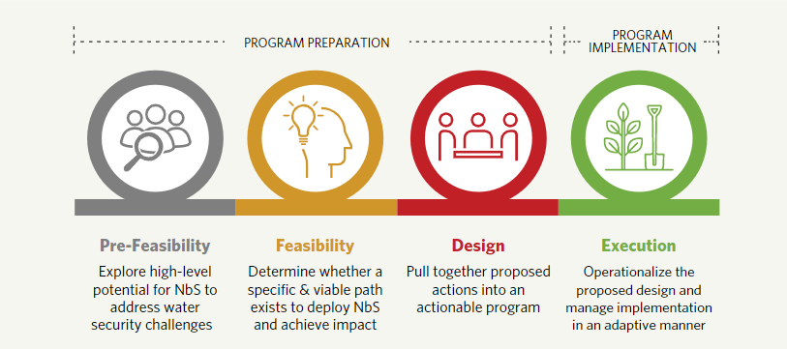
Figure 1 The four phases in the lifecycle of a Watershed Investment Program

- WIP partners

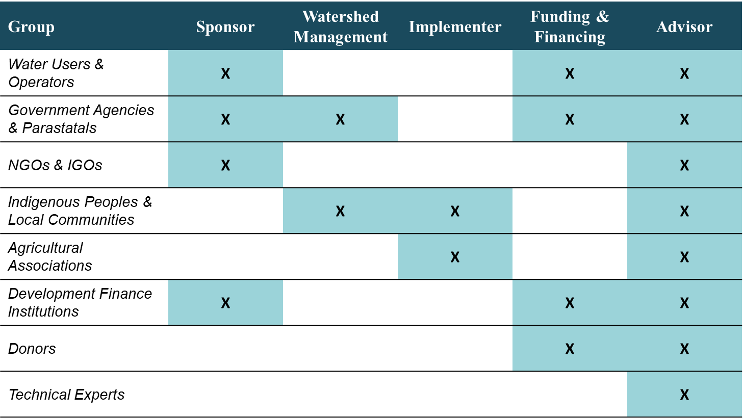
Figure 2 Typical partnership roles played in WIPs, presented by institutional grouping

- Sample interview questions
For all interviews, seek to ascertain their level of interest in and impact on the development of your WIP, as well as their willingness to be involved in the process.

Please see below for a list of additional sample interview questions to ask different types of stakeholders.

Stakeholder type | Sample interview questions
Watershed manager | Are you involved in the design, management or implementation of any other NBS projects?  Do you have a mandate to manage/supply water in the watershed?  What are your primary environmental concerns?  Have you financed any NBS projects?
Implementer | Are you involved in the implementation of any other NBS projects?  Do you have any concerns for the implementation?  Have you partnered with others on NBS or water security?  Would you be interested in partnering with us to design and implement the WIP?
Funding and financer | Have you financed any previous NBS projects?
Advisor | Would you be interested in partnering with us to design and implement the WIP?

- Typical watershed stakeholders and funding

Figure 3 Linking watershed stakeholders to Water Security Challenges, associated co-benefits, and opportunities for direct funding & alignment of deploying existing resources

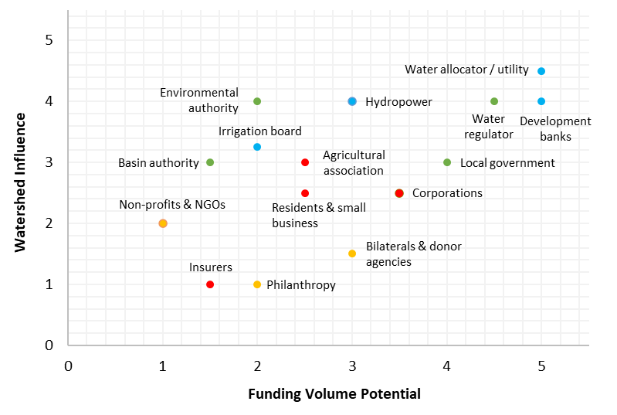
Colour legend
Green: Public actors
Blue: Public/private actors
Red: Private sector
Yellow: International cooperation

Figure 4 Beneficiaries mapped to typical funding volume and level of watershed influence
- Potential WIP governance models
COMMON GOVERNANCE MODELS

Umbrella Agreement: an agreement – usually an MoU or collaborative charter – between multiple parties outlining how they will and will not work together to accomplish a shared goal. In this model stakeholders often execute their own, separate implementation plans based on their own theory of change, and signatories agree to loosely coordinate with one another on certain aspects; most commonly, sharing data around implementation and monitoring & evaluation. Signatories do not usually work together to mobilize funding, but that is not always the case. The exception is usually when applying for public funds where it may benefit many programs to jointly apply, especially if the funding pool requires match.

Hosted Program: one organization primarily manages the development of the WIP but is usually guided by a Steering Committee of relevant partners. Relationships are typically defined in a Memorandum of Understanding (MoU) or Administration Agreement. As the program moves through the phases and its objectives become more defined, the hosted program may choose to develop one or more Working Groups or Sub-Committees focused on specific aspects of the program, like monitoring & evaluation, that may benefit from dedicated attention.

Dedicated Vehicle: an autonomous, legal entity with its own staff and standard operating procedures. The most common Dedicated Vehicle is a tax-exempt organization, also commonly referred to as a not-for-profit, non-profit, or public benefit organization, which can take from 6 to 18 months to establish, depending on the country. For this reason, many WIPs wait until they’ve executed for a few years before exploring the potential for a Dedicated Vehicle.

- Indicative Theory of Change
Colour legend
Green: New funding potential
Blue: Opportunity to align resources with existing mandates
Grey: Interest but unclear direct funding potential.
WUA stands for Water users Association

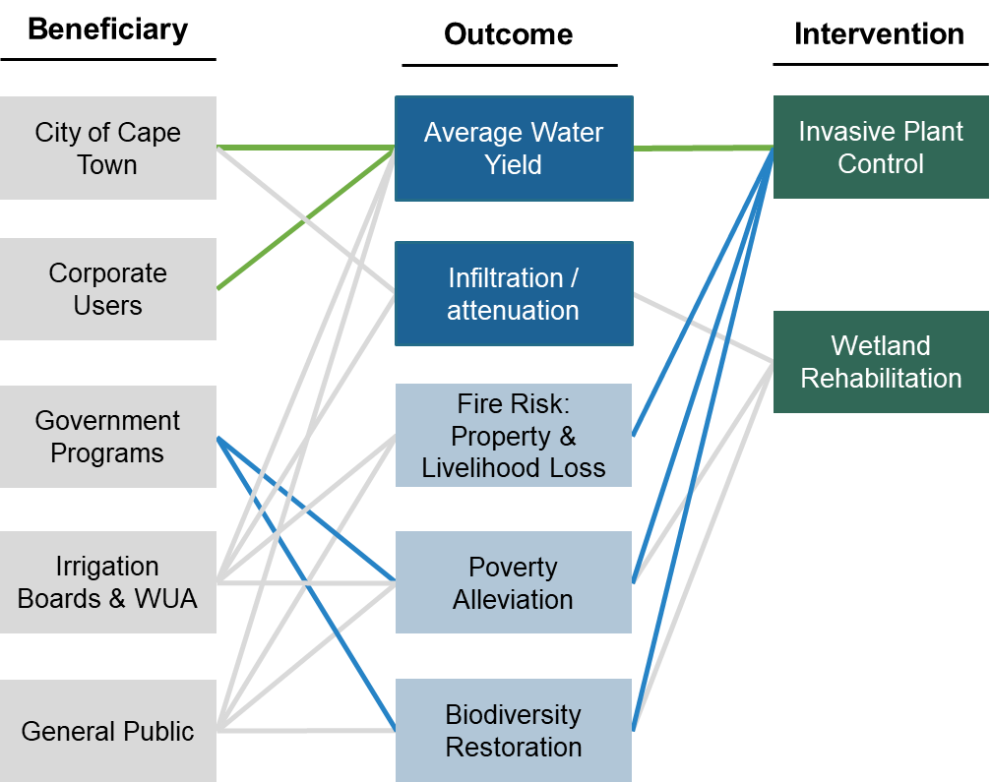

Figure 5 GCTWF indicative Theory of Change diagram that links beneficiaries with water security and co-benefit outcomes and the NbS interventions that generate those outcomes.
By developing your indicative Theory of Change, you should be in a position to:
- Formalize your understanding of the context and determine how your chosen interventions are linked towards the water security challenge(s) that the WIP seeks to address. You will need to outline the evidence behind your assumptions, during which you may find evidence gaps or be presented with conflicting evidence which requires a change in approach to address the problem or additional data gathering. The two key objectives of this are to (i) thoroughly assess the strength of the evidence base for the various linkages in the TOC; and (ii) to identify the key variables that affect the likelihood of attaining the desired outputs and outcomes.
- Clearly articulate your vision to key stakeholder and partners. This will enable you to garner support and co-operation, but also to gain their inputs into the TOC. The process of developing the TOC should be participatory and undertaken with your partners in order to capitalise on their expertise and develop a more robust TOC.
- Identify potential issues and risks, as well as potential opportunities, which you can then plan to mitigate or take advantage of in the design of your process.
- Engage with stakeholders to share your WIP’s vision and help them understand how they can be impactful by joining the process.
- Clarify and document all assumptions, in the process making them explicit and transparent so that the WIP can revisit and revise as a critical part of adaptive management

- Suggested Timeline
The below is an indicative timeline for the activities in this ToR, which can take between 5-7 months. Months 6 and 7 are buffer months, which are to be used if the stakeholder outreach assessment takes longer than expected.

Grey, D., & Sadoff, C. (2007). Sink or Swim? Water Security for Growth and Development. Water Policy. 9. 10.2166/wp.2007.021.
Typically, this group consists of a select few members who are confident of the benefits of the WIP, provide financial support for the subsequent phases of the WIP, and have the convening power to engage other stakeholders. Examples of stakeholders who are members of the Steering Group include: local water utilities, NGOs, private companies (e.g., beverages, food, etc.), local environmental agencies, banks, and universities. The members of this group usually serve on the Board of Directors once the WIP is created, and thereby shape the WIP's objectives, mission, and strategies.

